Part B: explore the arts as an audience member
Event log
Name: Ben Bull
Date: 2/6/15
What I attended: Russel Cotes Museum and Pavilion Dance
What evidence have I got that I went? (eg. tickets, programmes, photographs)
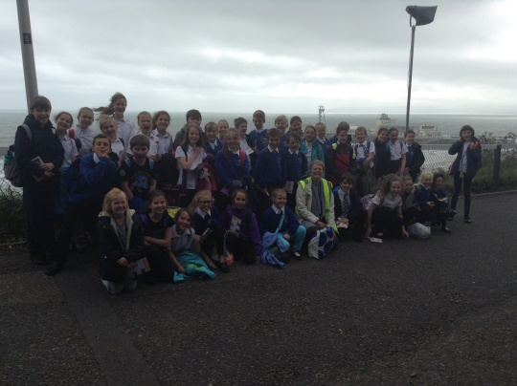
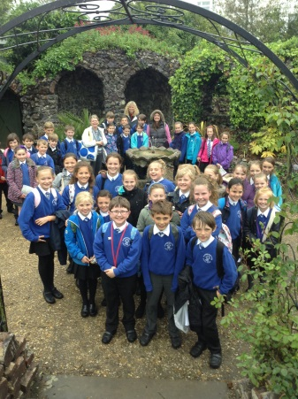
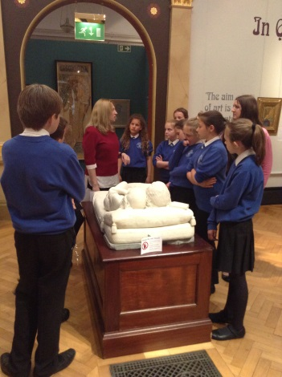

What happened at the arts event? What art forms were involved?

At Russell-Cotes museum we toured around the house and looked at famous paintings, sculptures, rugs and old furniture. The arts involved were painting and sculpting. Also, we went to the pavilion dance and had a tour around there. We got to see: 2 studios, a person doing some dance (choreographing) and a dressing room. After the tour, Katie came in and taught us a street dance routine to ‘Lips are movin’ by Meghan Trainor. The arts involved with the pavilion dance were dance.

Why I went to this event:

I went to Russell-Cotes museum because to actually be at the house and to see the gallery about Mucha. Also, we went there as all of the house is an art gallery.

The things I liked and why:

I liked touring around the museum as it was very interesting to learn the history of the Russell-Cotes family and to see all the artefacts just like sculptures, rugs and paintings. I also enjoyed the street dance (Pavilion Dance) because it was fun and a good experience. It was a good experience as I see people on TV doing dance and wonder what it is like to street dance and then I actually did it. Also, it was fun because when we got to hard bits of the dance we all had a laugh. Overall, I thoroughly enjoyed it but there were some downsides to it.

Part B: explore the arts as an audience member
Event log

The things I didn’t like and why:

I didn’t like the self-tour in Russell-Cotes as it was all over the place. One thing that I didn’t like about the self-tour was that when we had a proper tour it was all organized because we went upstairs and looked around the whole of upstairs and then we covered all of downstairs. Our tour however was self-lead by Rebecca Morgan. Firstly, we went upstairs and went into a room but then trekked across the second floor to get to a different room. Also, when we were at the Pavilion Dance our tour dragged on for a bit as we were in 1 studio and then we would stand there for 6 minutes telling us about it and then go to a different room and so on.

I would/would not recommend it to others because:

I would definitely recommend this to others as I think they’d enjoy it as much as I did or maybe even more. Also, they were both an experience and I would love other people to experience the feeling too.

What I learnt from the experience:

I have learnt that in the Russell-Cotes time, your wedding dress was used for funerals and special events. Also, I learnt that the Russell-Cotes family went all over the world and collected objects to put in Annie’s house.

I plan to share this review with others by:

I’m going to put it on the C.M.S website so others can read it and reply on it so I can read their comments.

What event would I like to go and see next?
Go to the cinema and watch one of Anna Kendrick’s films as they always seem to pass the time so quickly.

