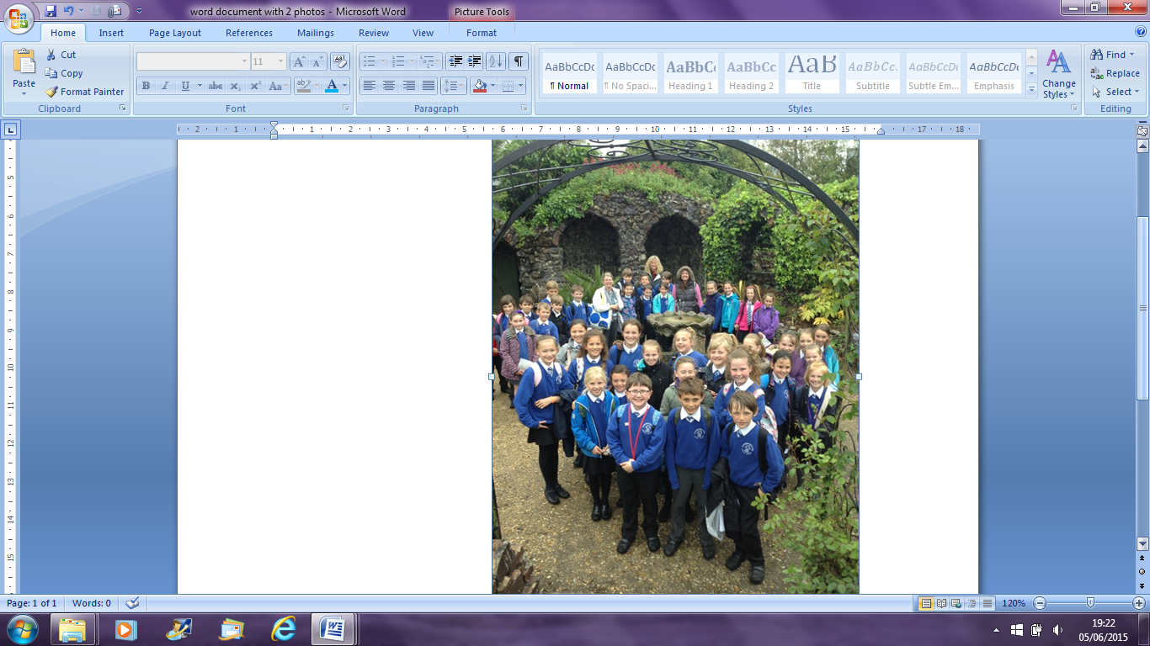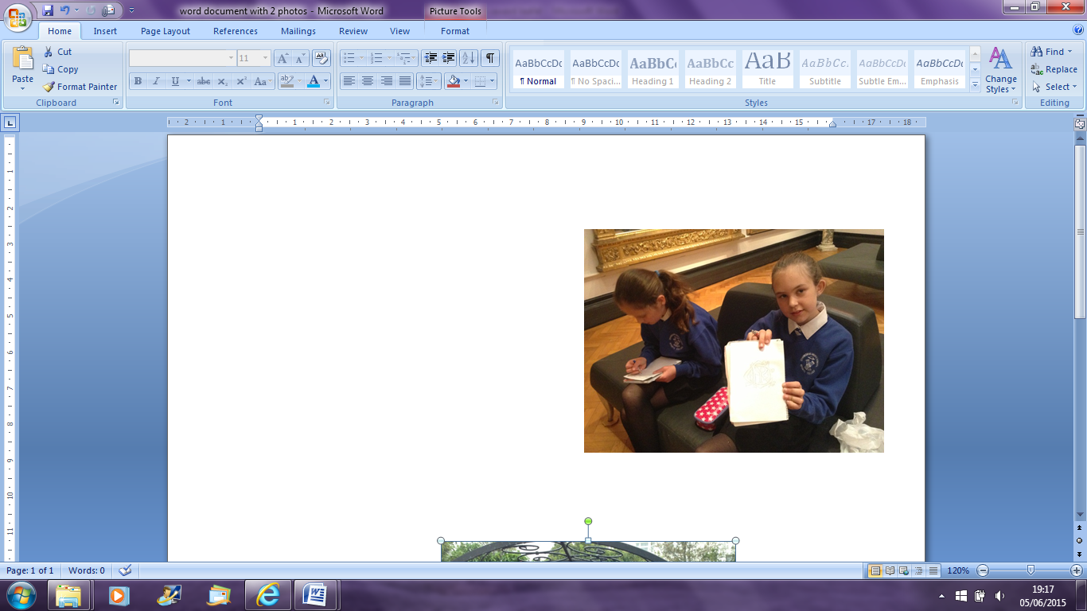

**I was here!**

**Opening Hours**

Monday closed

Tuesday 10:00am. -5:00pm.

Wednesday 10:00am. - 5:00pm

Thursday 10:00am. – 5:00pm

Friday 10:00am. – 5:00pm

Saturday 10:00am. – 5:00pm

Sunday 10:00am. – 5:00pm

Evidence that I went

